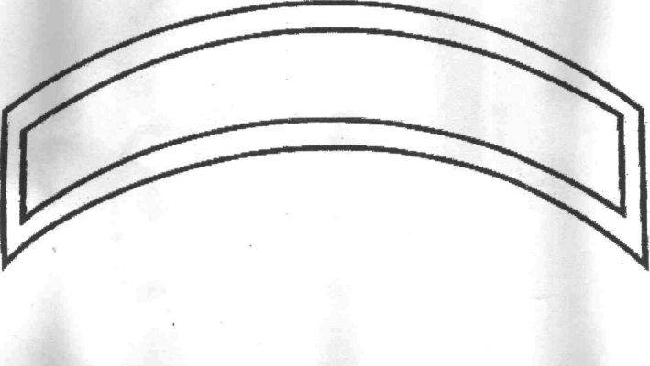
Choose Style: please circle one
Regular (black/gold)
Silver (light-reflective)
Print name or nickname onto rocker

___________________________ _____________________ _____________________
Full Name Phone Number Date ordered
Rocker Price: $9.00 Paid: Yes No

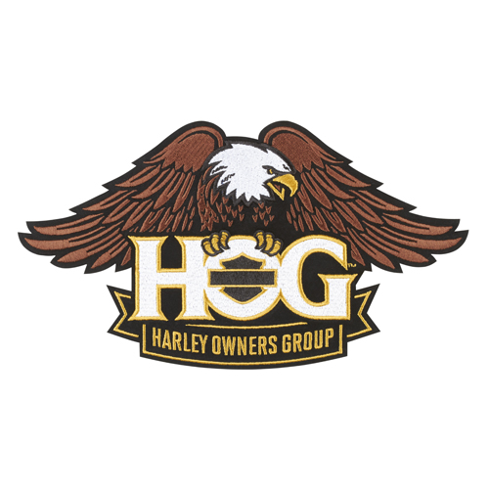
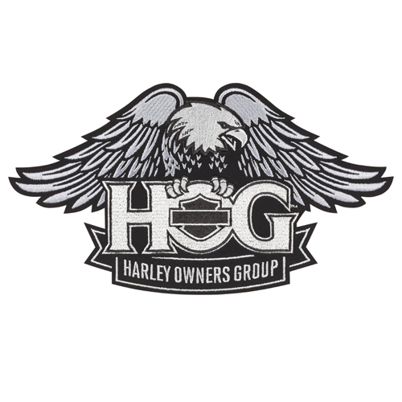


Large H.O.G. Patch Large Reflective H.O.G. Patch Large Winged Skull Patch

These three back patches, along with matching “Oakland CA Chapter” rocker may be purchased at
Oakland Harley-Davidson. Small sizes also available.

Glenn Martin-Treasurer
Oakland Harley Owners Group
510-316-4403
g.c.martin1829@sbcglobal.net

